
Shaftesbury Abbey CE VA Primary School
Marking and feedback policy 2026/2027

At The Abbey CEVA Primary School, we recognise the importance of feedback as an integral part of the teaching and learning cycle, and aim to maximise the effectiveness of its use in practice. We are mindful also of the research surrounding effective feedback and the workload implications of written marking, as well as research from cognitive science regarding the fragility of new learning. Our policy is underpinned by the evidence of best practice from the Education Endowment Foundation and other expert organisations.

The Education Endowment Foundation research shows that effective feedback should:
- Redirect or refocus either the teacher’s or the learner’s actions to achieve a goal
- Be specific, accurate and clear
- Encourage and support further effort
- Be given sparingly so that it is meaningful
- Encourage students to correct their own mistakes, rather than just providing correct answers for them
- Alert the teacher to misconceptions, so that the teacher can address these in subsequent lessons

Notably, the department for Education’s research into teacher workload has highlighted written marking as a key contributing factor to workload. As such we have investigated ways to provide effective feedback in line with the EEF’s recommendations, and those of the DfE’s expert group which emphasises that marking should be: Meaningful, manageable and motivating.

It is vital that we, as teachers, demonstrate, to pupils, how to respond to comments or improvement prompts in their work. Modelling, at all levels and in all classes will ensure pupils respond appropriately with sufficient thought and effort to make a difference in their work. Over time, children’s response will mature although the highest expectations should extend to corrections, improvement prompts and additional challenges.

Feedback and marking in practice
It is vital that teachers evaluate the work that children undertake in lessons, and use information obtained from this to allow them to adjust their teaching. Effective feedback is an integral and essential part of the learning dialogue between teacher and learner. We consider there to be three types of feedback which can impact on a learner’s progress:

Immediate Feedback
Immediate, live feedback given at the time and point of the learning incident is the most effective type of feedback. This will usually be verbal and could be for an individual child, a group of learners or for the whole class. Teachers will also constantly be seeking their own feedback on the progress of the lesson and the direction they need to take from that point onwards.

Summary Feedback
Summary feedback usually occurs at the end of a lesson or learning episode. It allows the teacher to summarise the key learning points and areas for development. It is also the opportunity for the teacher to link the current learning to the next steps. This time is also an opportunity for peer and self-assessment against agreed success criteria.

Review feedback
This type of feedback, including most written feedback and marking, takes place furthest from the point of learning. It is vital therefore that comments made allow learners to engage with, reflect upon and develop their learning from the piece of work.

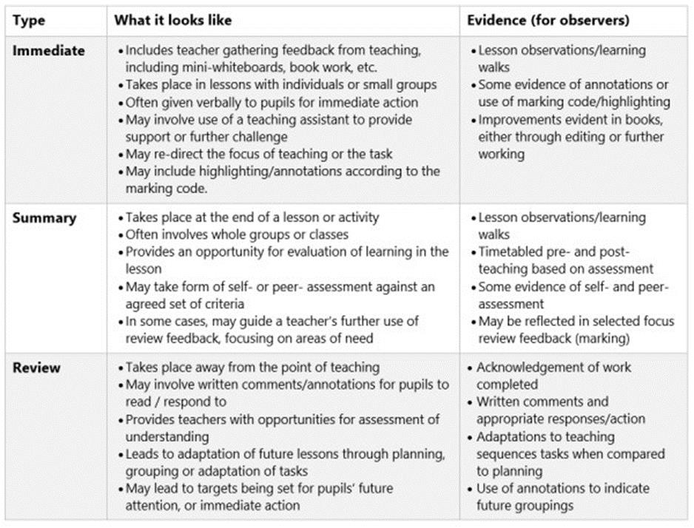

Effective Feedback should:
- Redirect or refocus the teacher’s or learner’s actions to achieve, or an improvement towards a desired learning goal.
- Clear, specific and accurate.
- Encourage and support further effort and learning resilience.
- Be meaningful.
- Provide specific guidance on how to improve and not just highlight error omissions and misconceptions.

Principles
- The sole purpose of feedback, including written marking is to further children’s learning.
- The process of feedback and marking will create the evidence that it is an ongoing, interactive and developmental process.
- Written feedback must be accessible and meaningful to the recipient. One deep mark a week.
- One independent every half term – with written feedback
- Feedback delivered as close as possible to the learning incident is most effective.
- Feedback is a two-way process. Throughout a lesson the teacher should be seeking feedback, through questioning, listening and observing, of the progress of the learners and be providing feedback to the learners of that progress.
- Feedback is part of the school’s wider assessment processes which aim to ensure a suitable level of challenge for all learners, and an array of strategies to ensure that each pupils learning is accurately measured and recorded.
- Written work produced by pupils should be reviewed at the earliest opportunity to ensure any feedback provided, written or verbal, can impact on the learners next steps.

At The Abbey CE VA school we aim to:
- Mark children’s work in a positive manner reflecting our ethos and enhancing the self-esteem and confidence of our children.
- Give verbal (VF) and written feedback regularly and consistently in ways which highlight strengths and shortcomings, using approaches which are understood by children and parents/carers.
- Provide a system of marking that is consistent and continuous across each stage within our school.
- Marking against Learning objective or Learning Question.
- Use marking to help target setting and future planning.
- Help children to recognise their difficulties and mistakes.
- Encourage children to accept help/guidance from others
- Show children the ‘next steps’ they need to take in their learning.

At The Abbey CE VA school we mark children’s work to:
- To help teachers monitor children’s progress and to diagnose what has not been understood so as to assist forward planning and learning.
- To provide helpful feedback to children making sure of the following:

- their needs are identified and we can discuss with them what they find difficult and the next steps they need to take
- their achievements are recognised thus giving encouragement and building confidence
- to show that work is valued and to praise
- to ensure set tasks have been carried out

At The Abbey CE VA school effective feedback and marking will:
- Provide clear feedback to the children about the strengths and weaknesses of their work relating to the learning objective set at the start of the lesson.
- Recognise, encourage and reward children’s efforts and progress.
- Encourage children to strive to improve.
- Direct children to what they need to do to improve their work and the next steps they need to take.
- Help parents/carers understand strengths and weaknesses in their children’s work.
- Enable children to review/renew their targets and understand the next steps they need to take in their learning.

The Abbey CE VA school Feedback and Marking Basics
- Staff will follow the Marking and Feedback Policy to ensure continuity and coherence in our approach.
- Children’s work will be marked and feedback given on a regular basis.
- Staff will use clear and legible handwriting when writing comments on children’s work.
- Comments made on children’s work will always be grammatically correct.
- Staff will use the Marking Codes for additional guidance. (see appendix)
- The children will use a purple polishing pen when making corrections or improvements to their work.
- Staff will use a pink pen (tickled pink) and Green pen (Green for Growth) when marking children’s work to show areas that need attention or those where the child has succeeded.
- Within written work not all spelling errors will be corrected by marking. Children will be encouraged to review their work using Common Exception words and dictionaries (especially KS2). Where the same common word is spelt incorrectly the teacher will write the word at the bottom of the page for the child to find the errors in their writing and correct them.
- Children will be awarded House Points/ Rainbow points/ Head teachers awards to praise excellent work and effort or improvement.
- Whole class editing sessions will be planned for in English.

Further Guidance
- Good presentation is always expected and may be marked in accordance with Curriculum policies, SEN policy and based on children’s individual abilities and needs.
- Children should be actively encouraged not to be ashamed of mistakes.
- Children should be encouraged to self-edit and improve work.
- Teachers/TAs can send a child to the Headteacher for additional praise and encouragement, for completing an especially good piece of work, showing improved effort and or progress towards individual targets, and of course, recognise the importance of informing parents/carers on such occasions.
- Appropriate comments or prompt questions will be written in language that the child understands. Comments will focus on and clearly identify what children need to do to improve. This assumes having comments read to them if they are non-readers.
- Every effort must be made to allow children time to reflect on comments written and then edit/improve their work.

Appendix
Marking codes
VF – verbal feedback given
I – Independent work
SP – spelling correction
P – punctuation errors
CL – Capital letters
G- Grammatical errors
// - new paragraph
T – Teacher supported
TA - Teaching assistant supported
PM – Peer marked
HP – House point

