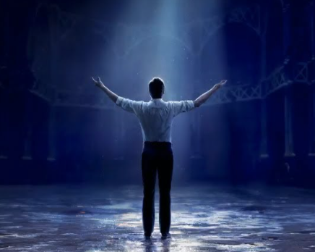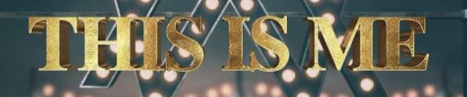

**Maths**

**White Rose**  Number – Place value (within 10)

Sorting, counting and representing objects. Counting forwards and backward. Comparing and ordering numbers.

Number – Addition and Subtraction

Parts and wholes, number sentences, fact families and number bonds within 10.

**Geography**

What is the geography of where I live?

**Art/DT**

Self Portraits – Assessment

AccessArt – Spirals

Mark making and making colour choices

Exploring spirals in nature, observational drawings of shells

Drawing using a continuous line

Exploring how water effects the pen

**Phonics**

**Little Wandle Letters and Sounds** – Phase 3-4 review + 4 phase 5 GPCs

Review tricky words phase 2-4

Revisit and review, practice and apply and read decodable books

Guided reading x three times a week

**Music**

Charanga – Hey You

**English**

**Fiction** – Stories with a familiar setting – relating stories to own experiences

Five Minutes Piece Stickman Knuffle Bunny Billys Bucket

**Non-Fiction –** information about our families

**RE**

God’s Creation

**PE**

**PE Hub -** Gymnastics

**Coach** – Multi-skills

**PSHE** – Jigsaw

Classroom charter

Being me in my world

Year 1 Autumn 1

**Science**

Animals including humans

Seasonal Changes