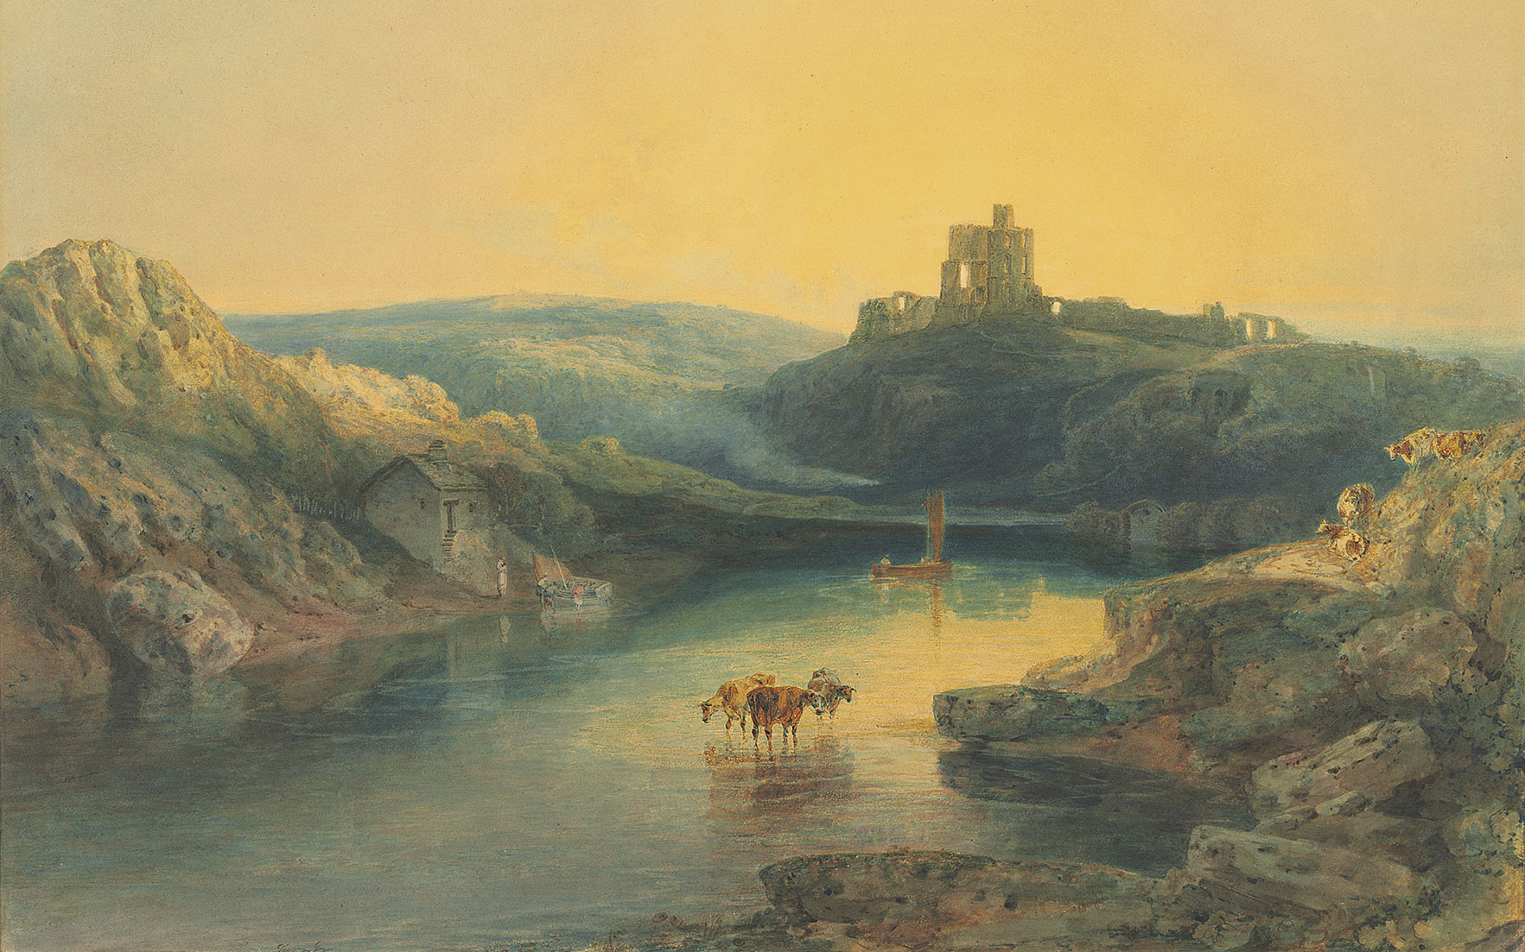
Literacy
Fiction: Traditional Tales and Fables Cinderella, Snow White and Billy Goats Gruff – Explore comprehension, SPAG and composition.
Poetry: Classic and Traditional Poems. Exploring different rhymes, poems and songs.
Non-Fiction: Researching life in a castle.
Geography
How does the weather affect our lives? What is the weather? How do great artists paint the weather? How does the weather change through the seasons? Why isn’t the weather the same everywhere in the world?
Maths
Multiplication and Division Counting in 2’s, 5’s and 10’s Making arrays, grouping and sharing
Fractions Finding halves and quarters
Measurement Money and Time
- 6. Your weather station: temperature
Art & DT
Drawing and painting castles, using a limited pallet Explore and recreate famous castle paintings by Turner
AccessArt – Flora and Fauna
PSHE
JIGSAW – Relationships Families Making Friends Greetings People who help us Being my own best friend Celebrating my special relationships

Once upon a Fairy Tale
Year 1 Summer
Science
Seasonal Changes - The Seasons
How many seasons are there? What are they called? Name a month for each of the seasons. Describe some of the changes that occur throughout the year.
Seasonal Changes – Day Length
Which season has longer daylight hours? Do all parts of the world have the same amount of daylight hours? What season is it in Great Britain when it is summer in Australia? Name 1 country in each of the hemispheres.

Phonics
Review phase 5 GPCs in preparation for phonics screening check.
Music
CHARANGA – Your Imagination Listen and appraise Musical Activities Performing the song

