Newsletter 6

Dear Parents and Carers,

This week we will present the Summer Reading Challenge certificates to all the children in our school who completed the challenge. We will be giving out 64 certificates, which is the highest number for any of the 183 Dorset primary or secondary schools who took part in the challenge! Well done to all those children, and to their families who encouraged them to take part.

We are also delighted to celebrate our school football team Being the Best they can Be in their new football kits at the Shaftesbury Family Football tournament last Wednesday. There were ten teams competing in this lovely event. We reached the final on goal difference after the group stages, and won the final 6-0!

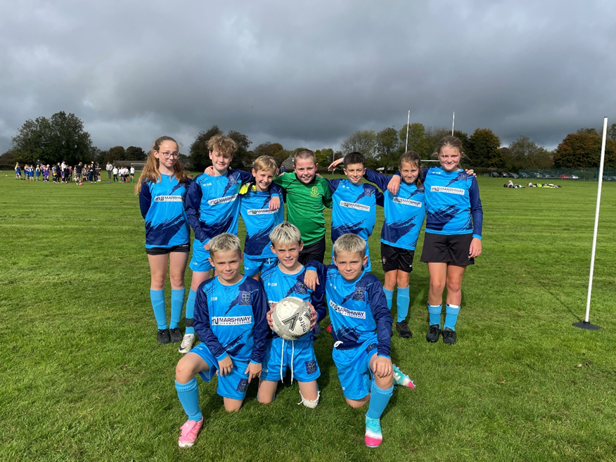

Here are the victorious football team in our new kit, kindly sponsored by Marshway Contracts.

**Individual Photos on Friday morning**

We have Stanley Baker coming in to school on Friday (17th October) to do the individual school photos, so please can all children come in to school in their school uniform (not PE kit) looking all smart and tidy! If they are doing PE that day, they just need to bring in a pair of trainers.

If you have a toddler who you’d like to include with your school-aged children, please come to the Hall at 8.30am.

**Parents evenings**

Bookings are still open for the following parents evenings:

**Thursday 16th October** - All year groups from Rec - Year 6 from 3.30 - 6pm

**Monday 20th October** – Rec, Year 1, Year 2, Year 3, Year 5, Year 6 from 3.30 - 6pm

**Tuesday 21st October** –Year 4 only from 3.30-5.30pm

You can book your parents evening appointments by logging in to the school website or the eSchools App which you can download onto your phone. The link to the school website is: [https://shaftesburyabbeycofe.eschools.co.uk](https://shaftesburyabbeycofe.eschools.co.uk/)

If you are struggling to book slots yourself, please ring the school office.

**Sports Leaders Report**

This report was written by Mrs Mitchell, who took our Year 6 Sports Leaders to their training last Monday:

This week, the spotlight has been on Heidi, Max H, Tallulah & Stanley, who were voted by their contemporaries in Y6, to be this year's Bronze Sports Ambassadors for our school!

As a result, on Monday 6 October, accompanied by Mrs Mitchell, they attended the annual North Dorset Primary Leadership Academy at Gillingham School, alongside other Y6 pupils from many other Primary Schools in our area.

The day started with an opening address by Nico, the N. Dorset Schools Coordinator & an introduction to the 3 visiting district Schools Games Organisers, who were to lead the teaching sessions and workshops throughout the day. In this, they were supported by some of the Y11 Sports Leaders from Gillingham School.

Our ambassadors had a busy and fulfilling day, completing many challenges, workshops and group tasks. All the activities were designed to improve their confidence, their leadership skills and to encourage them to share new ideas with others, on their return to school.

They worked well with their contemporaries from the other schools & appeared to enjoy sharing ideas and challenges with them.

They came away buzzing with enthusiasm and new ideas for activities and games at school. We look forward to them passing on their new-found knowledge!

For their hard-work & effort, they will be awarded the black 'Bronze Ambassadors' T-shirts which will identify them as leaders. They should wear them with pride.

We wish them all the very best for their tenure as School Sports Ambassadors & hope that they will be able to put into practice everything they have learned. Congratulations and good luck!

**Applications for secondary school and starting primary school in September 2026** (see info attached)

The secondary school date is coming along very soon! We recently heard from Dorset admissions that 18 Year 6 children were still needing to apply, please remind each other in this cohort, it is very important that these applications are received by the cut-off date. You stand a much greater chance of securing a place in one of your preferred schools if you apply on time!

For Secondary school starters in September 2026 (current Year 6 class), the closing date for **on time** applications is the 31 October 2025.

For Primary School starters in September 2026, the closing date for **on time** applications is the 15 January 2026.

**Light Party – at Father’s House on Friday 31st October from 6-7.30pm**

Please see the attached poster about this excellent event which provides a warm and friendly alternative to other things that go on that night!

**Half-Term Forest School in Semley**

Please see the attached information about Forest School in Semley over half-term, run by one of our Year 6 parents.

**Bag 2 School**

The Bag 2 School donation bags will be sent out this week, with collection date on 5th November.

**Christmas Dates**

For those of you who like to plan ahead, here are some dates we have in place in the run up to Christmas

28th November – Christmas Fayre, 3.15pm

9th December- Year 1 and 2 Nativity Performance, 2pm

9th December – Year 5 out to Larmer Tree pageant

11th December - Year 1 and 2 Nativity Performance, 2pm

11th December – Christmas Jumper Day for Save the Children

15th December – Christmas Pantomime trip for the whole school, 11.30am-4.30pm

16th December – Reception Nativity, 2pm

17th December – Local Food Links Christmas Lunch

17th December – Carol Service, 2pm in St James Church

18th December – Circus Performance, 1.45pm

19th December – Last Day – Pick up at 1pm

**Forest School – Tuesday afternoons**

Our Forest School day has changed to Tuesdays for the year ahead. It will be Year 4 again this week, then Reception from 21st October for the next three weeks.

Children need to have trousers and long-sleeved tops, wellies and a waterproof coat (with over-trousers if they have them). The Forest School philosophy is to wear the right clothing to go out in all weathers.

Michael Salisbury, Head teacher

**TERM DATES 2025 – 2026**

**Autumn Term**

**INSET DAY Wednesday 3rd September 2025**

Children start back Thursday 4th September 2025

Autumn Half Term Monday 27th October – Friday 31st October 2025

Autumn Term ends Friday 19th December 2025

Christmas Holidays Monday 22nd December 2025 – Friday 2nd January 2026

**Spring Term**

**INSET DAY Monday 5th January 2026**

Children start back Tuesday 6th January 2026

Spring half term Monday 16th February to Friday 20th February 2026

Spring Term ends Friday 27th March 2026

Easter holidays Monday 30th March to Friday 10th April 2026

**Summer Term**

**INSET DAY Monday 13th April 2026**

Children start back Tuesday 14th April 2026

MAY DAY Bank Holiday Monday 4th May 2026

**INSET DAY Friday 22nd May 2026**

Summer half term Monday 25th May to Friday 29th May 2026

Summer Term ends Tuesday 21st July 2026

**INSET DAY Wednesday 22nd July 2026**