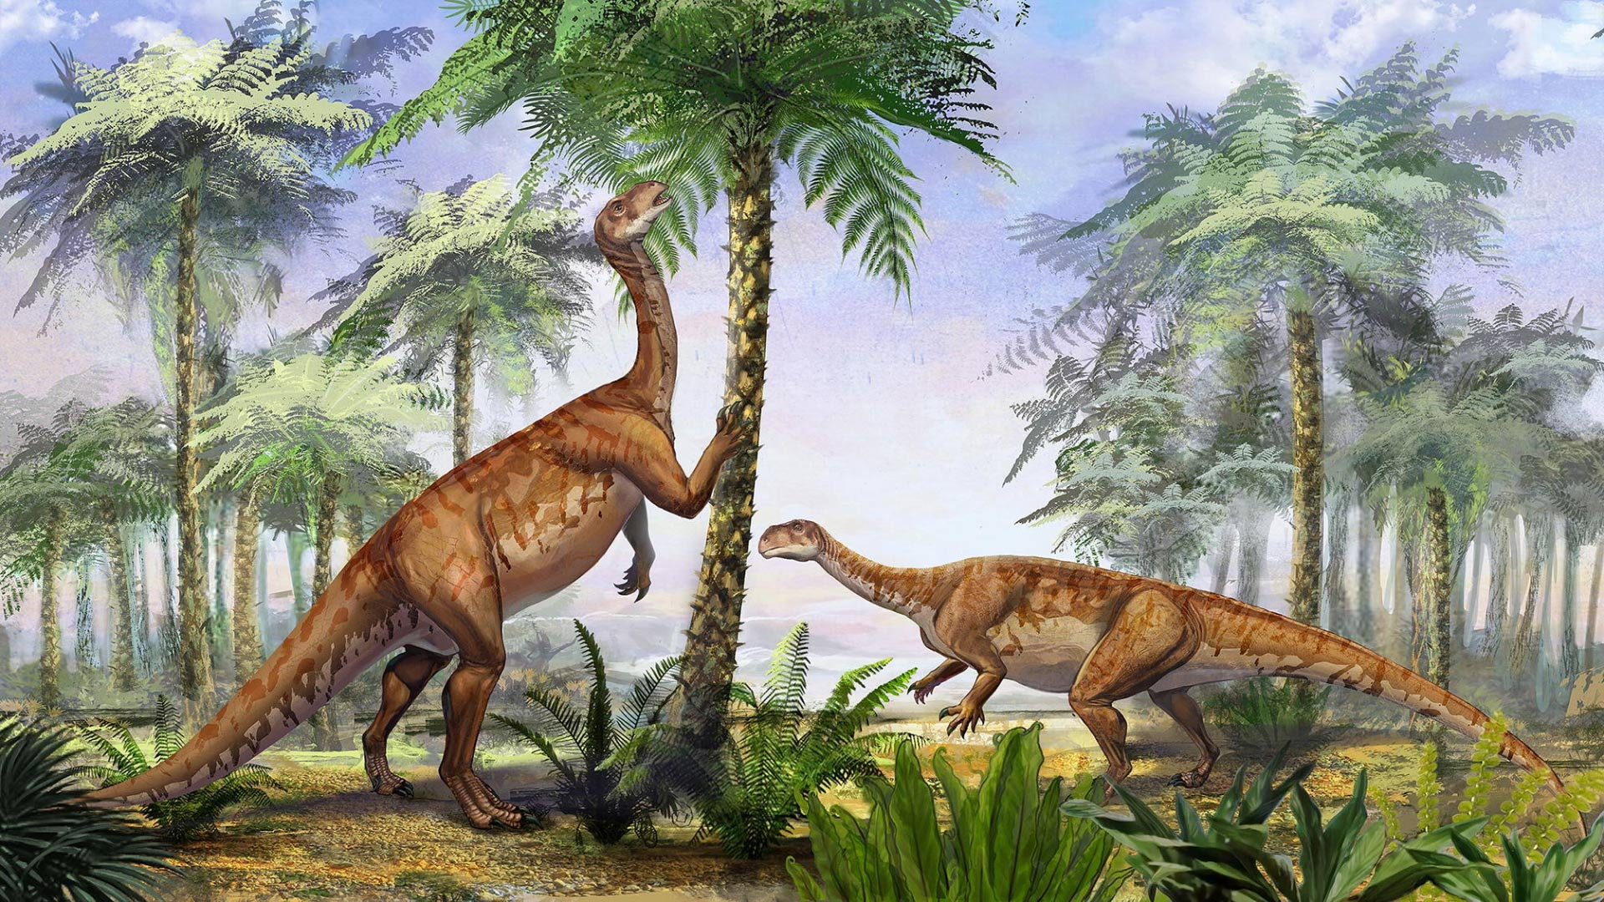
Art/DT
Exploring different skin textures. Focus on reptiles. Observational drawings, creating scales. Making our own fossils using clay. Designing and creating our own hand puppet. Explore simple running stitch, combining choices of fabric.

Science
Biology – Plants – Planting – Identifying Plants
Is a tree a type of plant? Can you name the parts of a tree? What is a plant? What is a tree? What is a leaf? How are leaves different? What type of tree did this leaf come from?

RE
Judaism
PSHE
Jigsaw – Changing Me
Dinosaur Discoveries
Year 1
Summer 2
Literacy
Reading and sorting fiction/non-fiction writing questions Learning about Mary Anning Writing a report Describing dinosaurs Reading ‘Harry and his bucketful of Dinosaurs’ Reading Comprehension

History
Why is the History of my locality significant?
- Why was one of Britian’s wealthiest Abbeys built in Shaftesbury?
- Why was Shaftesbury Abbey dissolved in 1539?
- Who was King Alfred the Great? Why was he so important to Shaftesbury?
- How did the first world war effect the lives of people in Shaftesbury?

Music

How Does Music Teach Us About Looking After Our Planet?

Explore sound and create a story.
Listening, singing, playing, performing

Phonics
Review Phase 5 GPCs for phonics screening check
New tricky words busy beautiful pretty hour
move improve parent shoe
Little Wandle guided reading using decodable books
Maths
Number Place value within 100
Measurement Money and Time

