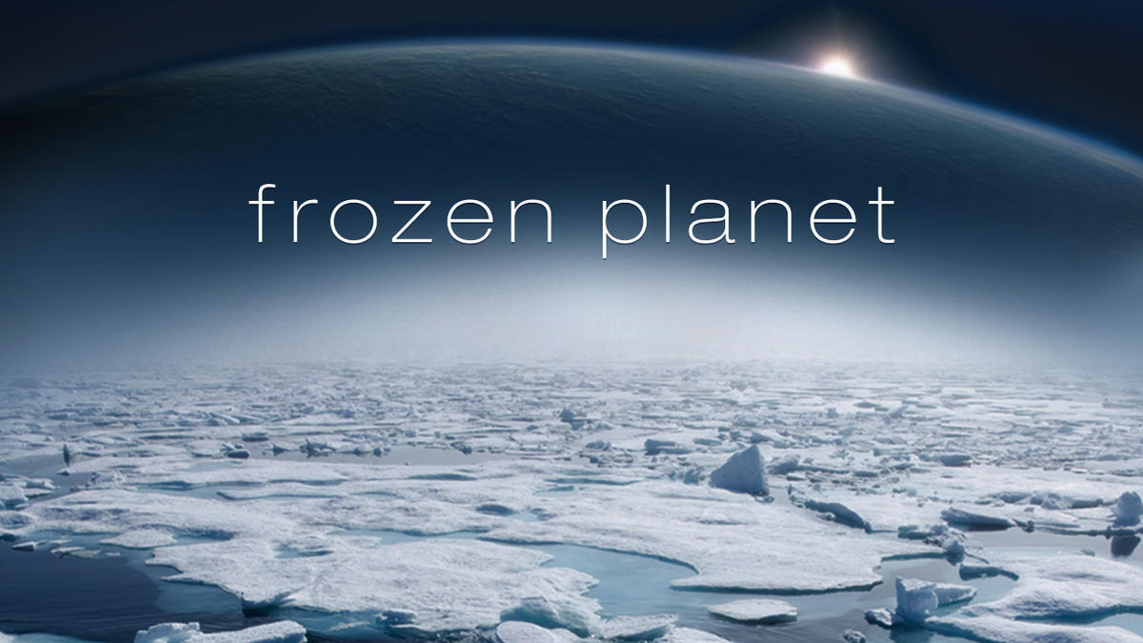
Year 1
Spring
Music
Charanga - In the Groove
Listen and appraise Musical Activities Performing the song

Phonics
Little Wandle Letters and Sounds – Phase 5 GPCs Review all GPC’s and tricky words
Phase 5 tricky words
Revisit and review, practice and apply and read decodable books
PSHE
Dreams and Goals
My treasure chest of success
Steps to goals
Achieving together
Stretchy learning
Overcoming obstacles
Celebrating my success
Maths
White Rose
Number – Place value (within 20) Addition and subtraction (within 20) Place value (within 50)
Measurement - Length & height Mass & volume

Art & DT
AccessArt
Working in 3D – Playful Making
What is sculpture? How can I manipulate materials? How can I use materials, tools, and ideas to invent? How can I reflect on my sculpture?

Science
Chemistry – Everyday materials
An introduction to materials Testing Materials Waterproof and Absorbent Materials Other properties of materials Stretchy and Bouncy materials
Ice investigations

Geography
Why don’t Penguins need to fly?
Where is Pip’s home and what do we find there?
How are penguins able to survive in Antarctica?
How does Antarctica compare with the Sahara Desert?
How is the Arctic different from the Antarctic?
Why are there no Polar Bears in Antarctica?
Why do Marco and Polo find visiting each other so difficult?
So why don’t penguins need to fly?

English
Fiction – The Emperor’s Egg
Little Pip series
Non-Fiction – Researching Antarctica using information books and internet
Poetry - First Dog on the Moon
by David Orme

Describing settings
Writing labels and captions
Writing letters, diaries and postcards
Own poetry using senses
Writing fact files and creating own creature from the Antarctic.

Continuing to follow our presentation promise, forming all letters correctly.

