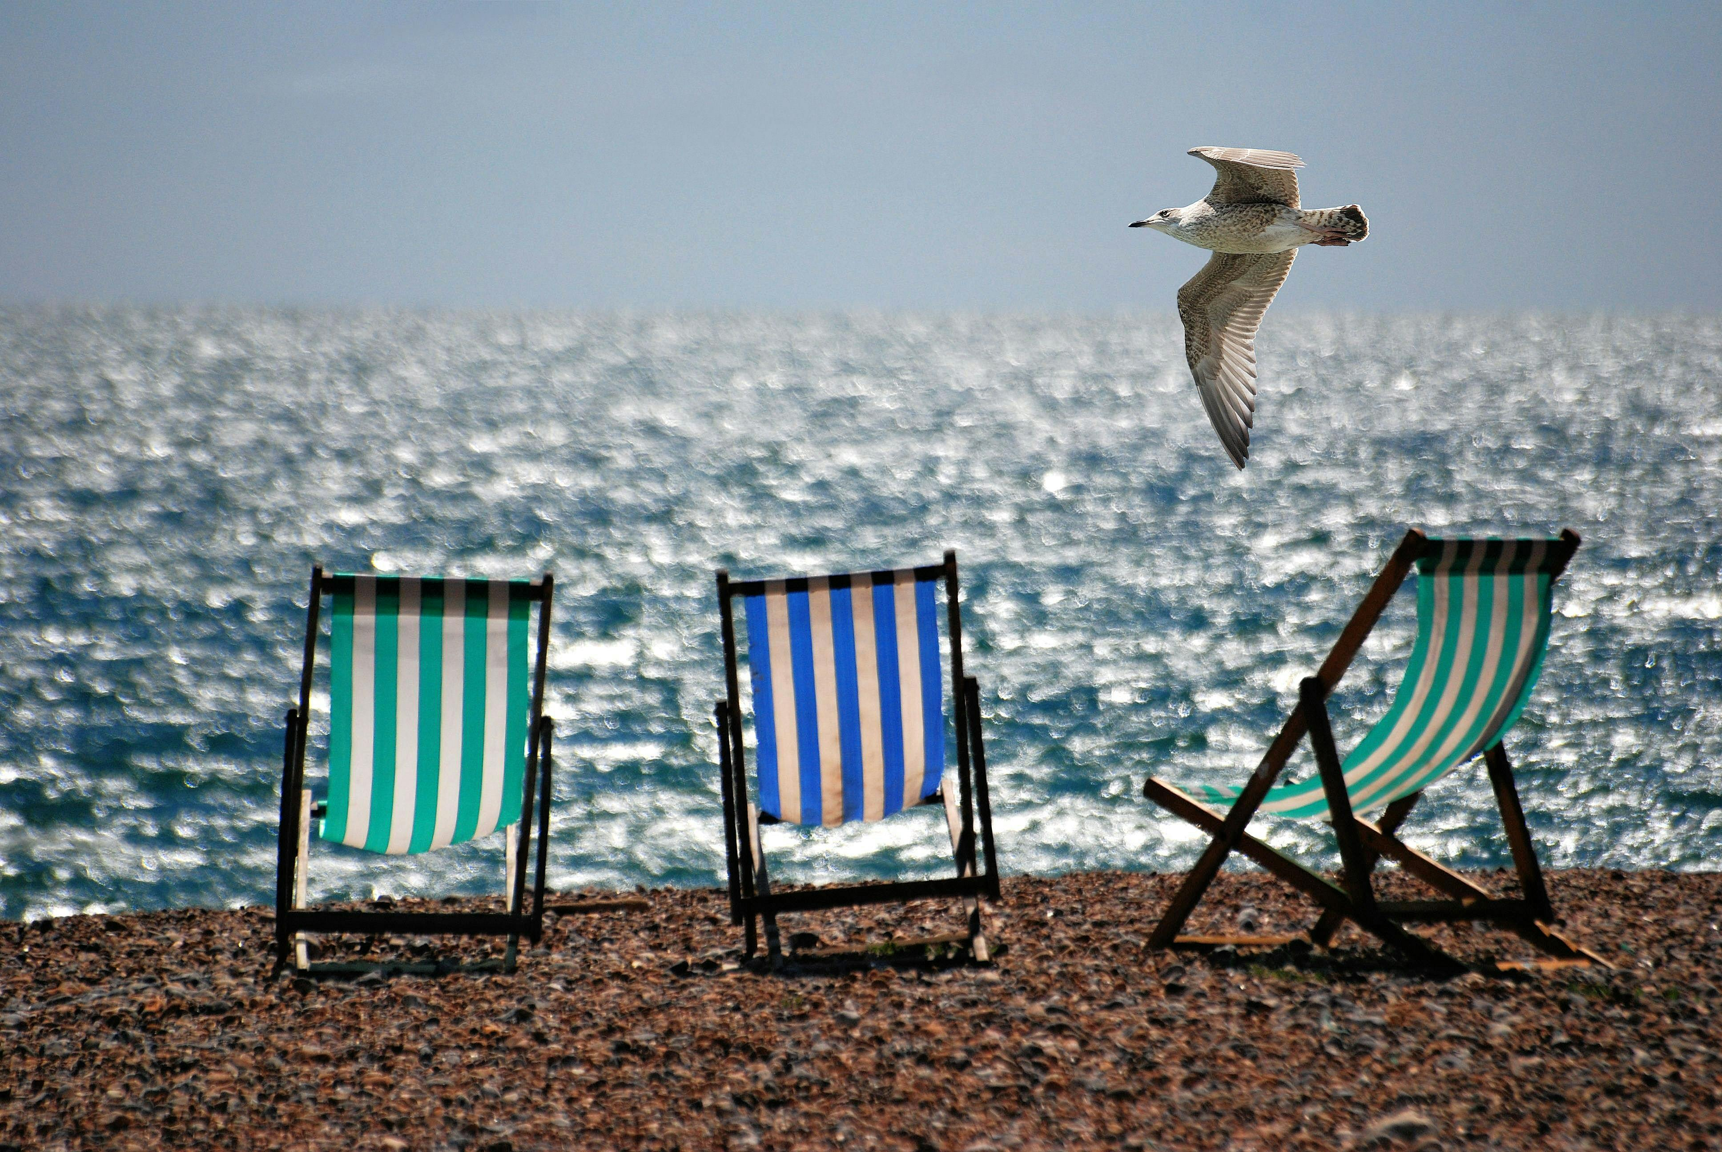
PE
In PE we will be developing our games, gymnastic and dance skills.
We will be working with a coach once a week in games.

Music
We will explore our own
vocal sounds and body percussion. Nativity songs.

RE
We will be learning about Creation and what Christmas means to
Christians.
PSHE ~ Using our Jigsaw scheme
~ Being me in my world and
Celebrating differences.

Computing
We will be ...
~ using coding skills
~ learning about E-Safety.

Art and Design Technology
In art we will be ...
~ sketching techniques
~ use natural resources to create art.
In DT we will be designing making and evaluating our own sandwiches.

History/Geography
Our history inquiry question is ‘Why was Charles sent to prison? ’We will be investigating features of World War 1.
Our Geography inquiry question is ‘Why do we love being beside the seaside so much?’ We will explore features of seaside resorts, what we all enjoy about them. How they have changed over time and what creatures live there!

Science
Our topic for the first half of the term is Healthy Animals including humans. We will learn about growth and survival. We will look at healthy living, eating and exercise.

Year 2 Autumn 2025
Maths
~ Place Value within 100, partitioning numbers, spelling numbers
~ Addition and subtraction, adding and subtracting 3 numbers,
Adding and subtracting 10, across a multiple of 10.
~ Number bonds up to 100, fact families.
~ Shape, 2D and 3D shape properties, symmetry.
~ Money and 3d /2d shape.

English
This term our English learning will initially link to our Geography Topic where we will use Samson’s Titanic Journey and Bubbles story to inspire our writing enabling children to build on the skills taught in Year 1. We will also explore Non –fiction animal texts linked to our Science as well as instructional text. We will continue to have daily phonics lessons and reading activities where children will read once a week in a Guided Reading group.

