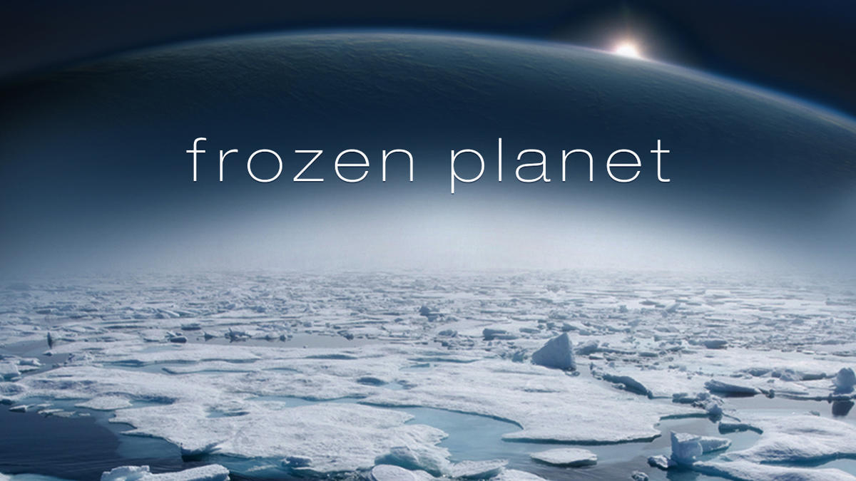

Music

Charanga - In the Groove

Listen and appraise Musical Activities Performing the song

Phonics

**Little Wandle Letters and Sounds** – Phase 5 GPCs Review all GPC’s and tricky words

Phase 5 tricky words

Revisit and review, practice and apply and read decodable books

PSHE

Dreams and Goals

My treasure chest of success

Steps to goals

Achieving together

Stretchy learning

Overcoming obstacles

Celebrating my success

Maths

**White Rose**

**Number** – Place value (within 20) Addition and subtraction (within 20) Place value (within 50)

**Measurement** - Length & height Mass & volume

Art & DT

AccessArt

Working in 3D – Playful Making

What is sculpture? How can I manipulate materials? How can I use materials, tools, and ideas to invent? How can I reflect on my sculpture?

Science

Chemistry – Everyday materials

An introduction to materials Testing Materials Waterproof and Absorbent Materials Other properties of materials Stretchy and Bouncy materials

Ice investigations

Year 1

Spring 2024

Geography

Why don’t Penguins need to fly?

Where is Pip’s home and what do we find there?

How are penguins able to survive in Antarctica?

How does Antarctica compare with the Sahara Desert?

How is the Arctic different from the Antarctic?

Why are there no Polar Bears in Antarctica?

Why do Marco and Polo find visiting each other so difficult?

So why don’t penguins need to fly?

English

Fiction – **The Emperor’s Egg**

**Little Pip series**

Non-Fiction – Researching Antarctica using information books and internet

Poetry - **First Dog on the Moon**

*by David Orme*

Describing settings

Writing labels and captions

Writing letters, diaries and postcards

Own poetry using senses

Writing fact files and creating own creature from the Antarctic.

Continuing to follow our presentation promise, forming all letters correctly.