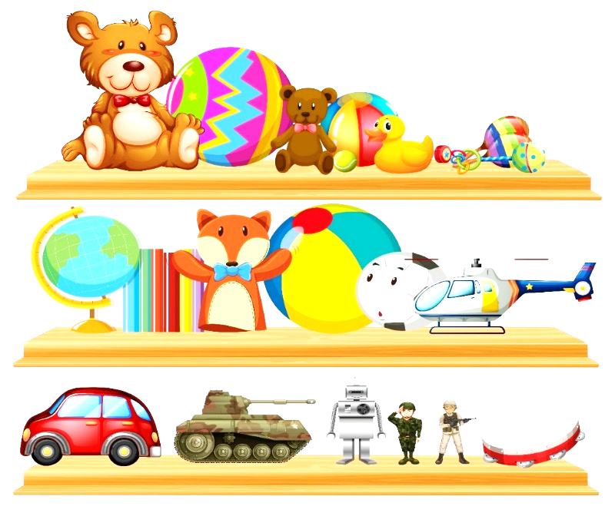
RE
Incarnation - Why does Christmas matter to Christians?
World Day – Let’s explore different faiths from around the world
Spiritual Development – Discus and reflect of different spiritual questions.
English
Fiction – Velveteen Rabbit, Billy’s Bucket, Lost in the Toy Museum Explore alliteration Poetry – Humorous Poems Develop reading and comprehension skills and stimulate writing using Oi Frog! & Oi Dog! Study syllables, the prefix un- and suffixes –ing and –ed. Begin to understand past/present tense. Fiction – The Clock Tower (The Literacy Shed) Descriptive writing, character, setting and narrative writing. Focus on correct letter formation and sentence structure.

Science
Animals including humans – Animals, teeth and diet
Seasons
Maths
White Rose
Number – Addition and Subtraction (within 10)
Geometry: Shape
Number – Place value (within 20)
Assessment – Maths.co.uk

History
Guy Fawkes – Remembrance Day
How do our favourite toys and games compare with those children in the 1960’s?
Explore toys used by Victorian children – Visit to the Gold Hill Museum

Phonics
Little Wandle Letters and Sounds – Phase 3-4 review + 4 phase 5 GPCs
Review tricky words phase 2-4
Revisit and review, practice and apply and read decodable books
PE
PE Hub – Unit 2 Dance
Coach – Multi skills
PSHE – Jigsaw
Celebrating Difference
Music
Charanga – Dance, sing and play
Learning Christmas songs/carols
TOYS
Year 1
Autumn 2

Art/DT
Design and Make a Toy Car
- Explore an existing product.
- Draw a simple design.
- Make a moving vehicle with a working axle.
- Start to understand what design criteria is used for.
- Evaluate what they did well on their product

